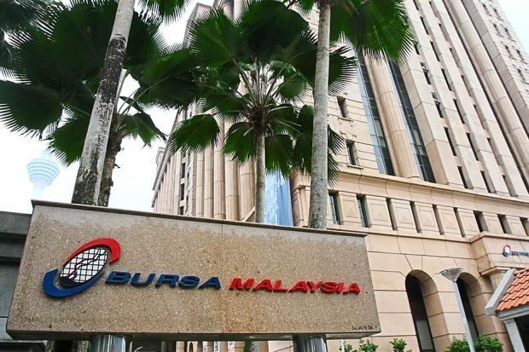

KLSE WEEKLY REPORT FOR

30/SEPTEMBER/2019

www.fortunateRESEARCH.com

KLSE STOCK MARKET:
MARKET SUMMARY:
The FBM KLCI index lost 8.86 points or 0.56% on Friday. The Finance Index fell 0.82% to 15317.36 points, the Properties Index dropped 0.88% to 776.7 points and the Plantation Index down 0.75% to 6723.57 points. The market traded within a range of 8.60 points between an intra-day high of 1592.05 and a low of 1583.45 during the session.
Actively traded stocks include GPACKET-WB, SAPNRG, MNC-PA, ARMADA, MNC, VSOLAR, BORNOIL, HSI-H6S, SUMATEC and SMRTRACK. Trading volume increased to 1881.20 mil shares worth RM1329.34 mil as compared to Thursday’s 1812.59 mil shares worth RM1610.54 mil.
Leading Movers were MAXIS (+6 sen to RM5.44), SIME (+2 sen to RM2.31), PETDAG (+12 sen to RM23.48), MAHB (+4 sen to RM8.67) and MISC (+3 sen to RM7.73). Lagging Movers were TOPGLOV (-15 sen to RM4.57), PMETAL (-9 sen to RM4.80), HLFG (-28 sen to RM16.10), SIMEPLT (-8 sen to RM4.80) and AMMB (-5 sen to RM4.11). Market breadth was negative with 287 gainers as compared to 483 losers.

TOP 5 ACTIVE COUNTERS:

NAME | LAST DONE | CHANGE | %CHANGE | VOLUME
GPACKET-WB | 0.275 | - | - | 1,097,812
SAPNRG [S] | 0.285 | - | - | 763,307
MNC-PA | 0.025 | - | - | 740,227
ARMADA | 0.35 | -0.015 | -4.29 | 672,851
MNC [S] | 0.105 | -0.025 | -23.81 | 662,332

TOP 5 TURNOVER COUNTERS:

NAME | LAST DONE | CHANGE | %CHANGE | VOLUME
MISC [S] | 7.7 | 0.03 | 0.39 | 73,066
PCHEM [S] | 7.52 | 0.01 | 0.13 | 58,223
MAYBANK | 8.7 | -0.1 | -1.15 | 43,317
RHBBANK | 5.59 | 0.01 | 0.18 | 58,372
PBBANK | 20.1 | -0.06 | -0.3 | 15,553

TOP 5 GAINERS:

NAME | LAST DONE | CHANGE | %CHANGE | VOLUME
DLADY [S] | 59.58 | 0.42 | 0.7 | 223
PENTA [S] | 4.27 | 0.22 | 5.15 | 26,070
TENAGA [S] | 13.42 | 0.18 | 1.34 | 20,627
PETDAG [S] | 23.36 | 0.12 | 0.51 | 3,078
SCIENTX [S] | 8.89 | 0.11 | 1.24 | 8,522
TOP 5 LOSERS:

NAME | LAST DONE | CHANGE | %CHANGE | VOLUME
AEONCR | 14.96 | -0.6 | -4.01 | 2,700
HAIO | 2.73 | -0.47 | -17.22 | 93,256
BAT | 19.2 | -0.36 | -1.88 | 4,964
CARLSBG | 26.3 | -0.32 | -1.22 | 906
CHINTEK | 6.5 | -0.31 | -4.77 | 22

TOP 5 % GAINERS:

NAME | LAST DONE | CHANGE | %CHANGE | VOLUME
INARI-C26 | 0.005 | 0.025 | 500 | 1
MTOUCHE-WB | 0.01 | 0.01 | 100 | 32,947
HIBISCS-CW | 0.015 | 0.015 | 100 | 2,413
INARI-C33 | 0.215 | 0.185 | 86.05 | 2
MISC-C22 | 0.045 | 0.035 | 77.78 | 400

TOP 5 % LOSERS:

NAME | LAST DONE | CHANGE | %CHANGE | VOLUME
HSI-H6O | 0.015 | -0.01 | -66.67 | 14,883
AXIATA-C36 | 0.27 | -0.175 | -64.81 | 98,902
AXIATA-C44 | 0.09 | -0.055 | -61.11 | 1,754
AXIATA-C41 | 0.105 | -0.06 | -57.14 | 6,100
AXIATA-C40 | 0.15 | -0.08 | -53.33 | 32,310

INDICES:

NAME | LAST DONE | CHANGE | %CHANGE | VOLUME
CONSTRUCTION | 205.42 | -0.12 | -0.06 | 487,368
CONSUMER PRODUCTS & SERVICES | 647.55 | -0.69 | -0.11 | 1,528,117
ENERGY | 1,077.44 | 17.09 | 1.61 | 4,251,580
FINANCIAL SERVICES | 15,516.70 | 37.53 | 0.24 | 407,370
HEALTH CARE | 1,255.57 | 2.5 | 0.2 | 154,032
INDUSTRIAL PRODUCTS & SERVICES | 149.04 | -0.08 | -0.05 | 1,698,139
PLANTATION | 6,827.21 | 20.27 | 0.3 | 125,843
PROPERTY | 784.17 | -1.77 | -0.23 | 892,954
REIT | 1,016.60 | 0.1 | 0.01 | 74,640
TECHNOLOGY | 33.32 | 0.34 | 1.03 | 586,830
TELECOMMUNICATIONS & MEDIA | 691.75 | -13.56 | -1.92 | 1,165,286
TRANSPORTATION & LOGISTICS | 766.59 | -0.33 | -0.04 | 503,736
UTILITIES | 983.68 | 6.14 | 0.63 | 148,343
FBMACE | 4,479.49 | 22.11 | 0.5 | 2,195,775
FBMAPMYR | 17,023.85 | 19.95 | 0.12 | 177,285
FBMAPUSD | 11,738.21 | 27.79 | 0.24 | 175,702
FBMEMAS | 11,241.79 | -39.33 | -0.35 | 8,696,681
FBMSHA | 11,746.43 | -79.86 | -0.68 | 4,115,211
FBMFLG | 14,242.46 | -55.73 | -0.39 | 2,816,022
FBMHIJRAH | 13,046.99 | -145.68 | -1.1 | 1,289,984
FBMKLCI | 1,595.85 | -8.62 | -0.54 | 1,747,965
FBM70 | 13,820.47 | 32.02 | 0.23 | 3,559,793
FBMMSCAP | 13,841.55 | 61.36 | 0.45 | -

KLSE
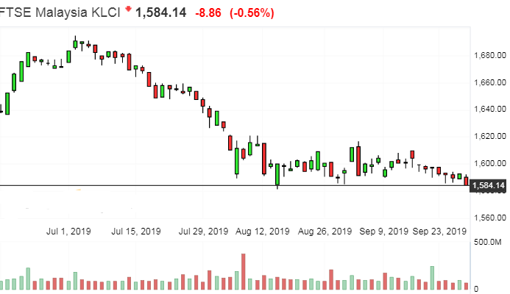

RESSISTANCE 1: 1600
RESSISTANCE 2: 1595
SUPPORT 1: 1585
SUPPORT 2: 1575
STRATEGY:
BUY ON DIPS
FORCAST MARKET INFORMATION FOR TOMORROW:
ON THE DAILY CHART KLSE INDEX IS IN CORRECTION UPSIDE. KLSE INDEX HAS BROKEN STRONG RESSITANCE LEVEL 1600 THERE IS A ANOTHER RESSITANCE LEVEL IS 1620 IF IT IS BREAKING THIS LEVEL THEN IT CAN GO MORE UPSIDE. KLSE INDEX MAY BE MOVE SOME CORRECTION UP TREND IN NEXT WEEK DAY.

BUMI ARMADA BHD
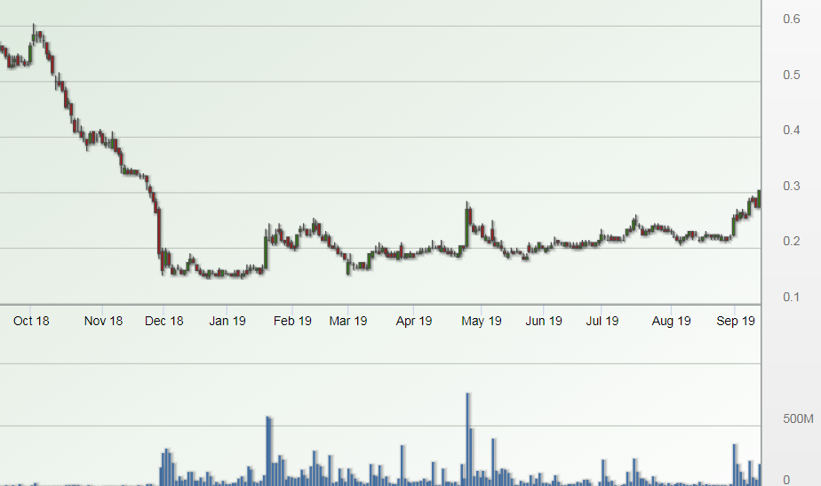

CALL FOR NEXT WEEK :
KLSE SHORT TERM CALL BUY ARMADA ABOVE 0.340 TARGET 0.400 / 0.500 STOPLOSS 0.270
www.fortunateresearch.com

DISCLAIMER
The information and views in this report, our website & all the service we provide are believed to be reliable, but we do not accept any responsibility (or liability) for errors of fact or opinion. Users have the right to choose the product/s that suits them the most. Investment in Stocks has its own risks. Sincere efforts have been made to present the right investment perspective. The information contained herein is based on analysis and up on sources that we consider reliable. We, however, do not vouch for the accuracy or the completeness thereof. This material is for personal information and we are not responsible for any loss incurred based upon it & takes no responsibility whatsoever for any financial profit s or loss which may arise from the recommendations above. The stock price projections shown are not necessarily indicative of future price performance. The information herein, together with all estimates and forecasts, can change without notice. FORTUNATE RESEARCH does not purport to be an invitation or an offer to buy or sell any financial instrument. Analyst or any person related to FORTUNATE RESEARCH might be holding positions in the stocks recommended. It is understood that anyone who is browsing through the site has done so at his free will and does not read any views expressed as a recommendation for which either the site or its owners or anyone can be held responsible for. Any surfing and reading of the information is the acceptance of this disclaimer.
Our Clients (Paid or Unpaid), any third party or anyone else have no rights to forward or share our calls or SMS or Report or Any Information Provided by us to/with anyone which is received directly or indirectly by them. If found so then Serious Legal Actions can be taken. Any surfing and reading of the information is the acceptance of this disclaimer.

All Rights Reserved.

